AWS Challenge -1

- Launch one EC2 instance using Amazon Linux 2.
- Launched an instance and named Aws challenge-1
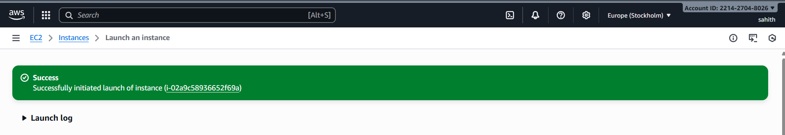
- First copy first copy the ssh instance to git bash.
- Install Docker.
sudo yum update -y
sudo yum install docker
systemctl start docker
systemctl status docker
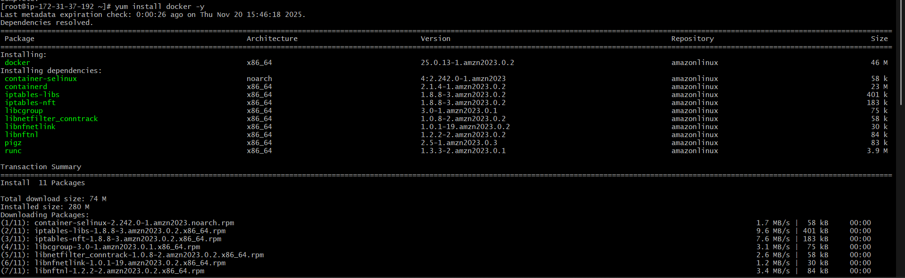

- Install Jenkins.
- first install java. for latest version install jdk 17
use the command yum install java-17-amazon-corretto -y
- Then check the java -version to install Jenkins sudo yum install jenkins -y
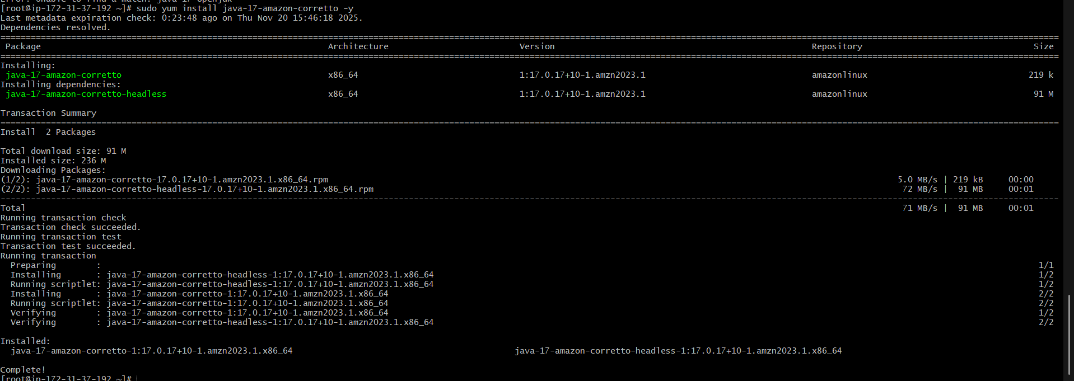
- systemctl start Jenkins
Systemctl enable jenkins
systemctl status jenkins
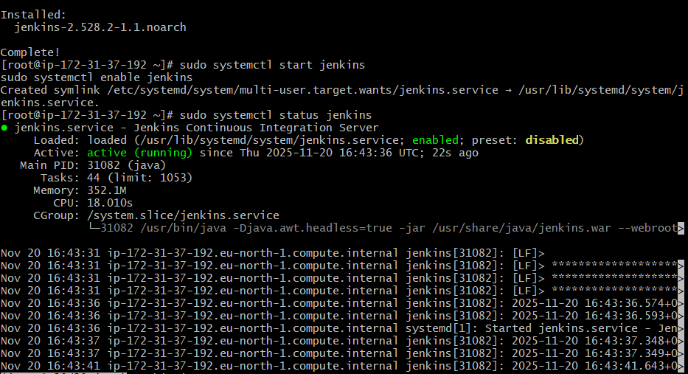

- Install Apache.
- yum install httpd -y, systemctl start httpd, systemctl enable httpd, systemctl status httpd.

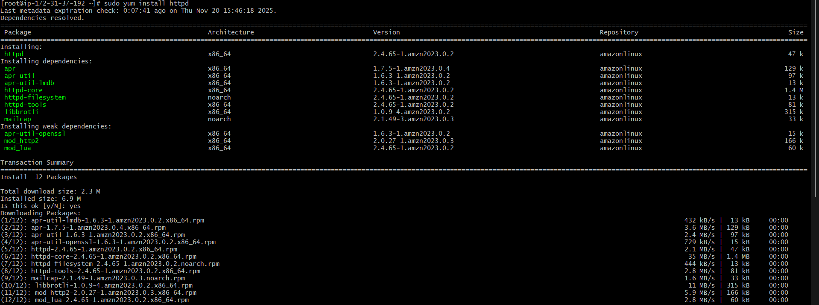
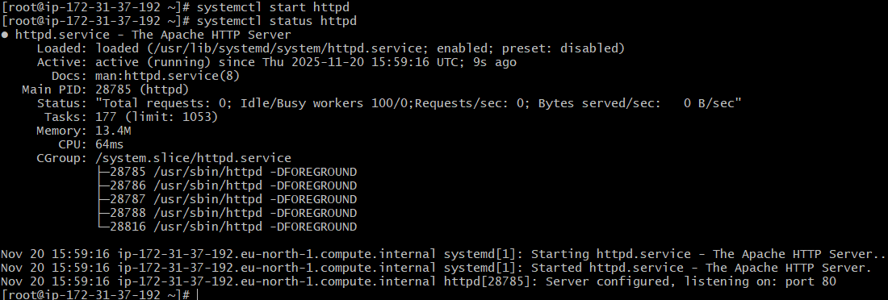

- Install Nginx.
- yum install nginx -y, 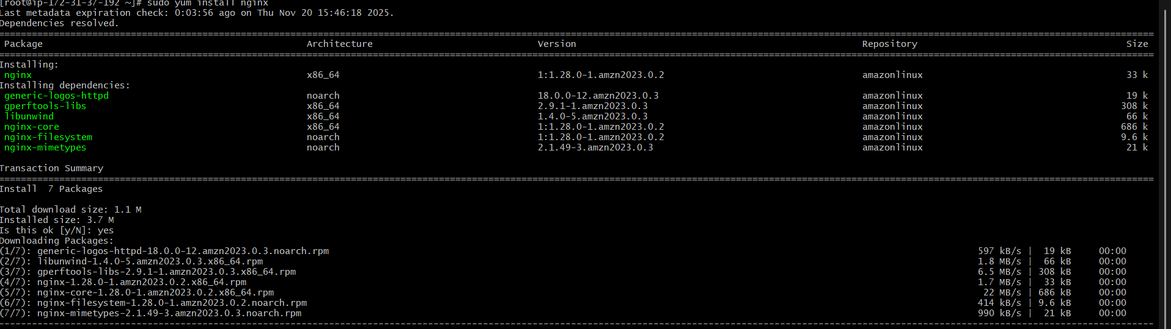
- systemctl start nginx, systemctl enable nginx, systemctl status nginx.
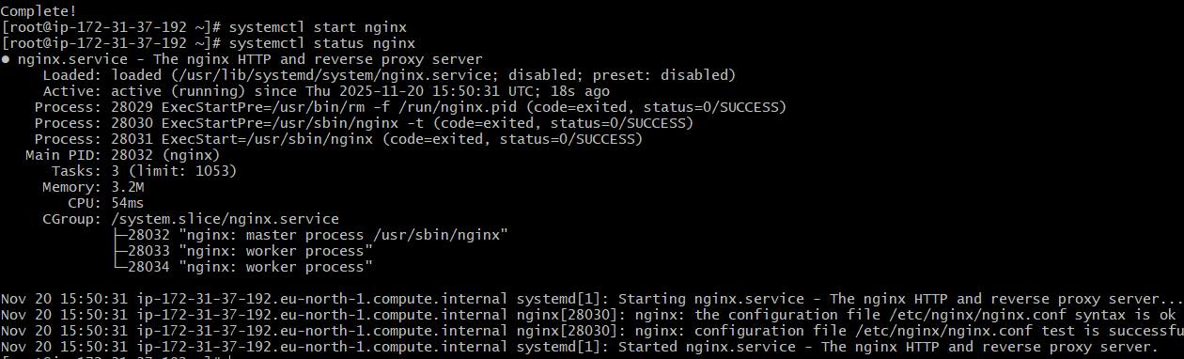
- Install Apache Tomcat.
- First copy link from browser using wget command paste the link and enter and ls
- Now, we can see apache-tomcat-9.0.112.tar.gz. unzip this using command tar xvf apache-tomcat-9.0.112.tar.gz
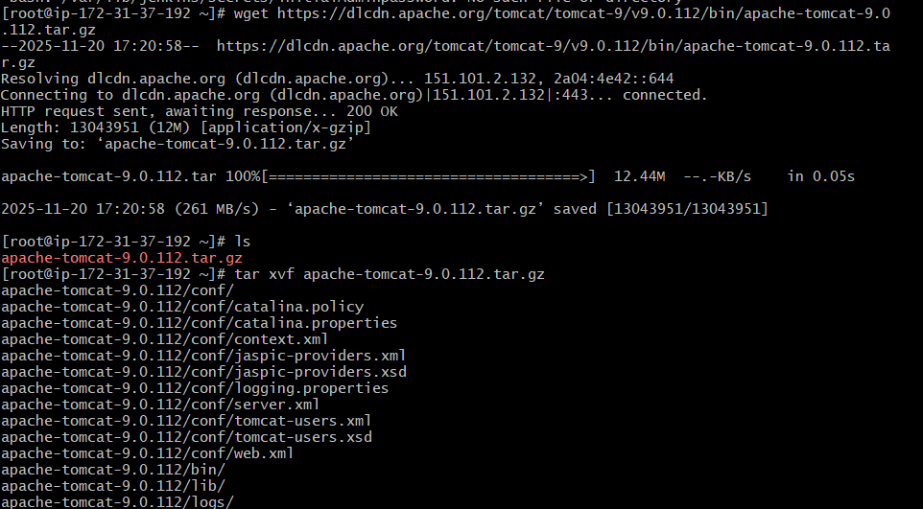
- Ls we can see this apache-tomcat-9.0.112 apache-tomcat-9.0.112.tar.gz. now, cd apache-tomcat-9.0.112/ > cd bin > ls > ./startup.sh and ./shutdown.sh

